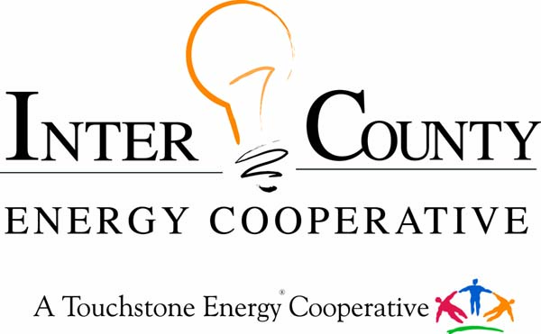

WASHINGTON YOUTH TOUR

Inter-County Energy is offering high school juniors a one-day trip to Frankfort and a once in a lifetime opportunity to tour Washington DC.
The Kentucky Rural Electric Washington Youth Tour is an annual, weeklong, all-expenses-paid trip to Washington, DC. Twenty-two of Kentucky’s 24 electric cooperatives participate in the Washington Youth Tour. Nationwide, electric co-ops from forty-six states participate. In all, more than 1,500 young people from across the nation gather in Washington, DC, each year for this event. Kentucky’s electric co-ops send students to Washington, DC, for a number of reasons including:
- rewarding students for academic achievement and community leadership;
- educating students about the role of electric co-ops in the national economy;
- fostering students’ appreciation for the democratic form of government;
- exposing students to the sights and sounds of our nation’s heritage.
PARTICIPATION REQUIREMENTS
1) Applicant must be an actively enrolled junior in good standing from one of the
following Inter-County Energy directorial districts: Boyle, Casey, Garrard, Lincoln, Mercer, or Marion County.

2) Applicant must submit a Washington Youth Tour Application, Transcript, and a Teacher Recommendation Letter. Deadline February 24, 2023

3) Winners will be required to attend the Frankfort Youth Tour the end of March, as well as the Washington Youth Tour June 11-16, 2023

DISCLAIMER: Youth Tour awards will be chosen by the decision of a panel of judges selected by Inter-County Energy Cooperative. All decisions of the judges are final. All materials, images, resumes, essays, and applications submitted by the applicant become the sole and absolute property of Inter-County Energy Cooperative and its affiliated companies. It is the sole decision and discretion of Inter-County Energy Cooperative to disqualify any applicant who does not comply with any of the entry and participation rules as set forth in the application process. Incomplete or inappropriate entries will not be considered for awards.

2023 WASHINGTON YOUTH TOUR APPLICATION
DEADLINE: Friday, February 24, 2023

Name_____________________________________ Age________ Email__________________________
Address_________________________________________ Cell Phone____________________________
High School Attending _________________________GPA_________ **Attach copy of Transcript**
Expected Graduation Date______________ Future Plans_______________________________________
Parents Names______________________________ Parents Cell Phone___________________________
Use additional paper as needed for all questions
List activities in which you have participated and special honors you have received during high school.
____________________________________________________________________________________
____________________________________________________________________________________
____________________________________________________________________________________
____________________________________________________________________________________
Have you visited Washington D.C., before? Yes or No ________ ________________________________

Why do you want to go on the Washington Youth Tour? _______________________________
____________________________________________________________________________
_____________________________________________________________________________
_____________________________________________________________________________
_____________________________________________________________________________
In your own words, describe the purpose of an electric cooperative? ____________________
_____________________________________________________________________________
_____________________________________________________________________________
___________________________________________________________________________
_____________________________________________________________________________
_____________________________________________________________________________

Mail your entry form to Inter County Energy, ATTN: April Burgess, P.O. Box 87, Danville, KY 40423 or email the form to april@intercountyenergy.net

Questions? Call 859-936-7822 or email april@intercountyenergy.net

