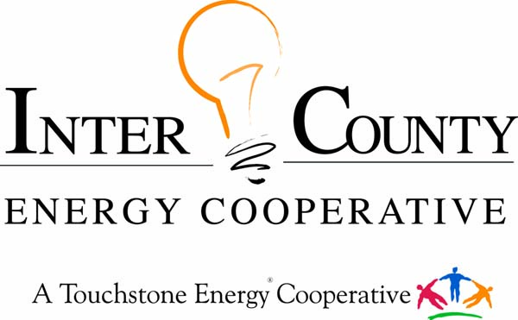

WASHINGTON YOUTH TOUR

Inter-County Energy is offering three high school juniors a one-day trip to Frankfort and a once-in-a-lifetime opportunity to tour Washington DC.
The Kentucky Rural Electric Washington Youth Tour is an annual, weeklong, all-expenses-paid trip to Washington, DC. Twenty-two of Kentucky’s 24 electric cooperatives participate in the Washington Youth Tour. Nationwide, electric co-ops from forty-six states participate. In all, more than 1,500 young people from across the nation gather in Washington, DC, each year for this event. Kentucky’s electric co-ops send students to Washington, DC, for a number of reasons including:
- rewarding students for academic achievement and community leadership;
- educating students about the role of electric co-ops in the national economy;
- fostering students’ appreciation for the democratic form of government;
- exposing students to the sights and sounds of our nation’s heritage.
PARTICIPATION REQUIREMENTS
1) Applicant must be an actively enrolled junior in good standing from one of the
following Inter-County Energy directorial districts: Boyle, Casey, Garrard, Lincoln, Mercer, or Marion County.

2) Applicant must submit a Washington Youth Tour Application, Transcript, and a Teacher Recommendation Letter. Deadline January 15, 2026

3) Winners are required to attend the Frankfort Youth Tour in February or March, as well as the Washington Youth Tour June 15-20, 2026

DISCLAIMER: Youth Tour awards will be selected by the decision of a panel of judges selected by Inter-County Energy Cooperative. All decisions of the judges are final. All materials, images, transcripts, letters of recommendation, and applications submitted by the applicant become the sole and absolute property of Inter-County Energy Cooperative and its affiliated companies. It is the sole decision and discretion of Inter-County Energy Cooperative to disqualify any applicant who does not comply with any of the entry and participation rules as set forth in the application process. Incomplete or inappropriate entries will not be considered for awards.

2026 INTER COUNTY ENERGY WASHINGTON YOUTH TOUR APPLICATION
DEADLINE: January 15, 2026

Full Name (as it appears on I.D.)__________________________________________________________

Date of Birth_____________ SSN_________________________ Do you have a Real ID? Yes or No

Are you a US Citizen_______ Country of Birth__________

Email ______________________________ Have you visited Washington D.C. before? Yes or No

Address_________________________________________ Cell Phone____________________________

**Attach copy of Transcript** **Please include a copy of your government issued ID**

Expected Graduation Date______________ Future Plans_______________________________________

Parents Names______________________________ Parents Cell Phone___________________________

Please answer the following questions on a separate sheet of paper.

1. Why do you want to go on the Washington Youth Tour?
2. In your own words, describe the purpose of an electric cooperative?
3. List of activities and awards you have received during high school.

Mail your application, transcript, photo ID and letter of recommendation to Inter County Energy, ATTN: April Burgess, P.O. Box 87, Danville, KY 40423 or email the form to april@intercountyenergy.net

Questions? Call 859-936-7822 or email april@intercountyenergy.net

